< Documentation Section >

< Article Title >
< Article text >

< Section title >
< Section text >

See also: < List of articles >

Author & Copyright: <Jan-Joost van Zon> Date: <May 21, 2008> – <May 22, 2008> Location: <Oosterhout, The Netherlands> Status: [ Under Construction | Finished | … ]

Ideas

Out of the original Symbol documentation

Tracing Object Aspects
…
The same way, type lines can redirect the interface. Object lines can redirect the type and the type can redirect the interface, so an object line can also direct the interface.

Interface Trace
You’ll use all three line types to trace the interface. Follow the interface line if it exists, else follow the object line, else the type line. When you run into a symbol with no lines, then that’s the interface.

A special thing about an interface line is that you can select a single interface of a type and not use the whole type.

When there’s no interface line and the type line is followed, then the type’s whole interface is used.

The reason that the object line is preferred over the type line is that if there is no interface line, the object can determine which interface of the type is used.

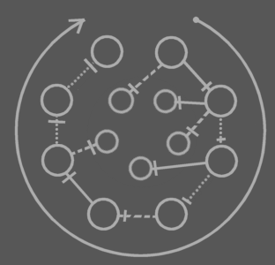
This picture shows any combination of lines an object symbol can have and which of the lines to follow in the interface trace.

In other words: follow interface line, otherwise object line, otherwise type line. The final symbol altogether is the interface.

Object-Type-Interface Trace
It happens frequently that you need a symbol’s target object, type and interface in one blow. That requires two traces: an object-type trace and an interface trace. The full operation is an object-type-interface trace. It deserves a separate name for it’s a very common operation.

Tracing Procedure Aspects

Procedure Interface Trace
In the procedure interface trace you follow both line types, but you prefer following an interface line over a reference line.

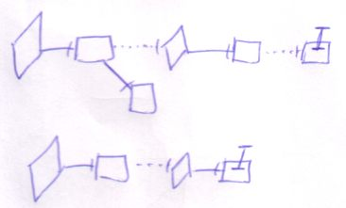

The last symbol of the trace is the interface.

Following any of the two line types will eventually lead to the same symbol. In that sense it doesn’t matter what line type you prefer to follow. The interface line is preferred, though, both because it’s more logical to follow, and because following them you’ll probably hit the interface sooner: probably there will be less interface redirections than reference redirections.

Execution-Definition-Interface Trace
It happens frequently that you need target execution, definition and interface in one blow. That requires two traces: an execution-definition trace and an interface trace. The full operation is called an execution-definition-interface trace. It deserves a separate name for it’s a very common operation.

Type Line Being called Interface Line
The term interface target can mean the target of the interface line, but there’s also a second meaning. When the interface line is missing, the interface can also be redirected by an object line or type line. The term interface target can also denote the symbol to which the interface is redirected, be it with an object line or type line. Sometimes the word interface line is even used where I really talk about the line that redirects the interface.

The same thing applies to the term type target. Type target can mean the target of the type line, but it can also mean the symbol to which the type is redirected, be it with an object line, be it with a type line. Sometimes the word type line is even used where I really talk about the line that redirects the type.

It’s the same thing with the redirection of other system aspects.

